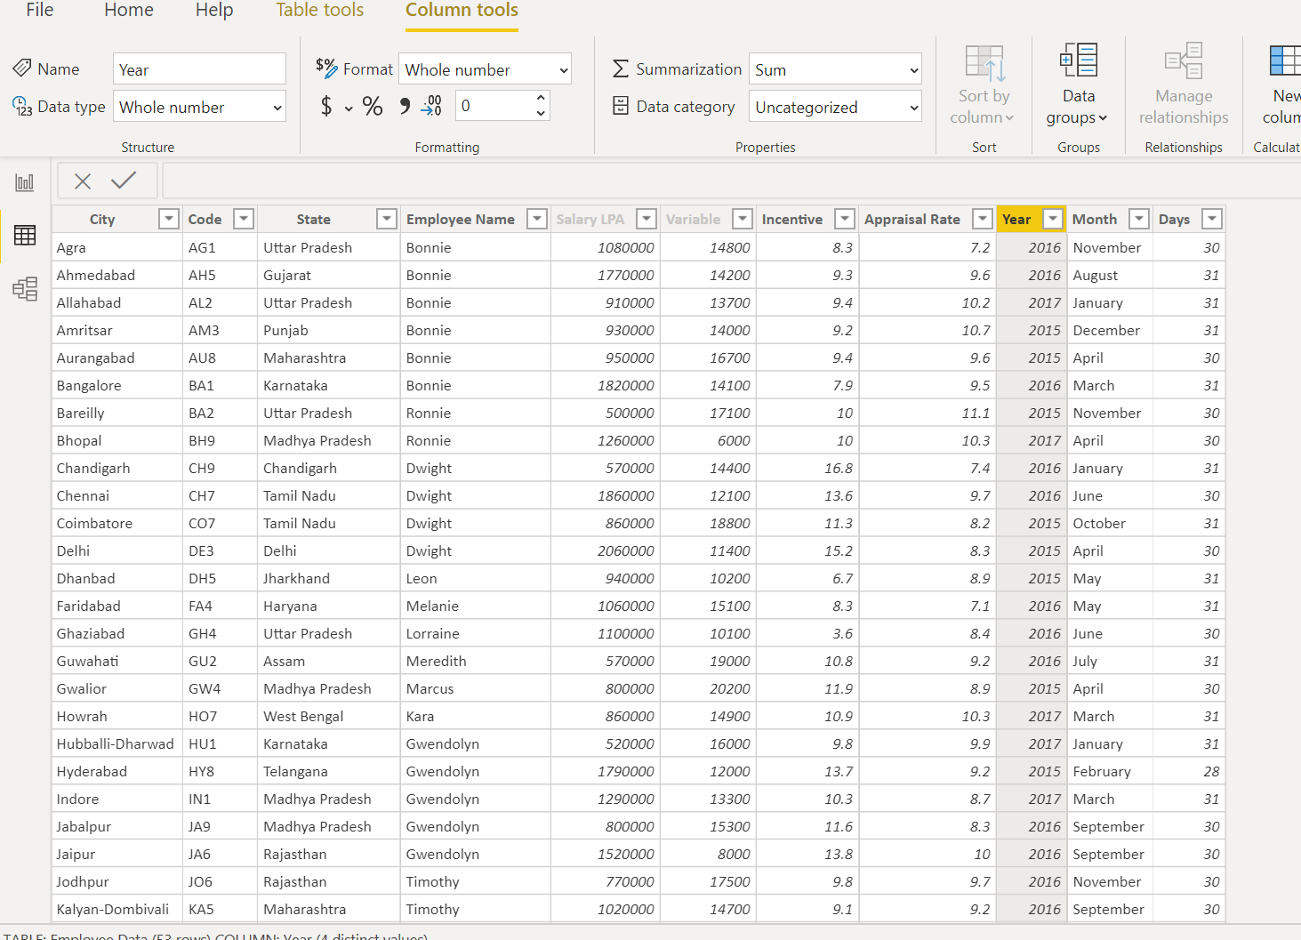

Table transformation as per the requirement

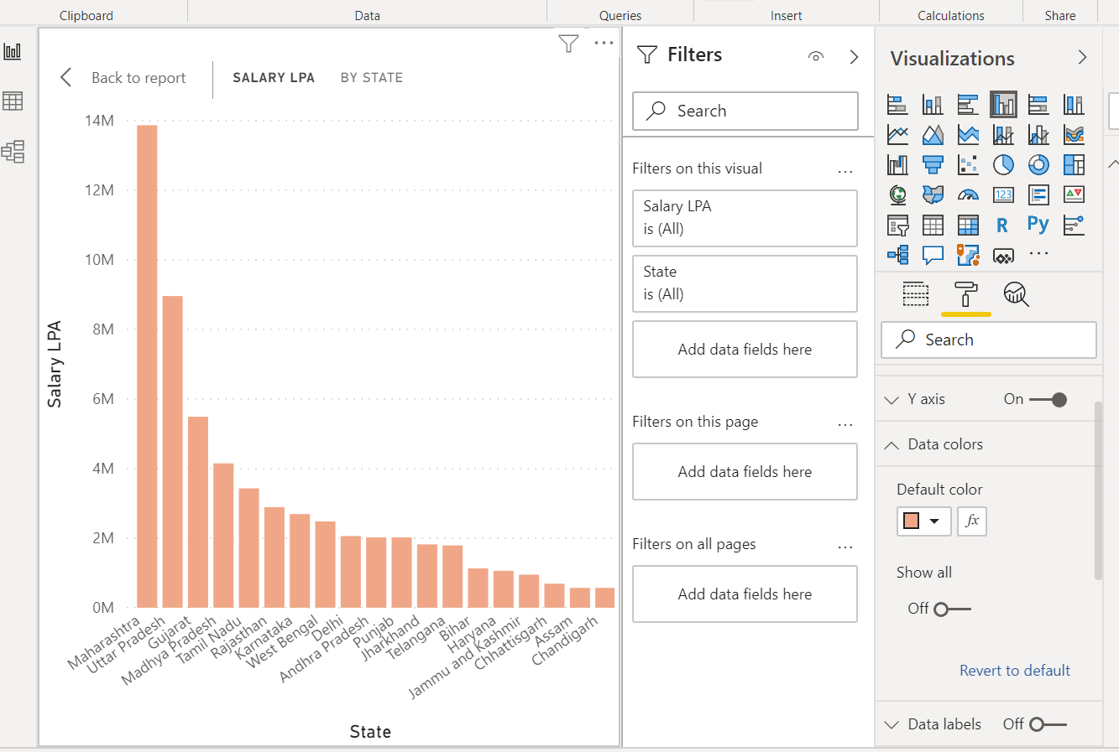

Minimum Salary is drawn by Assam state (570000LPA)